IPLA Annual General Meeting

Date: Wednesday 28th November 2018.
Time: 7pm GMT.
Venue: Skype Conference

Minutes
- Apologies - Will Roberts, Dominic Cunliffe, Fiona Diffey
- Present – Nigel Green, Margaret Whitehead, Elizabeth Durden-Myers, Hannah Goss, Cara Shearer, Dwayne Sheehan, Stuart Mc Reynolds, Liz Taplin, Jeanne Keay, Paul Roetert, Chris Topping, Sue Capel
- Minutes of the IPLA AGM 2017 – Accepted as true record
- Chair’s Report
Chair’s Report November 2018
My thanks go to the Committee members who have worked tremendously hard throughout the year to promote physical literacy worldwide. It has taken a lot of commitment to realise the wide range of successes that the IPLA has achieved throughout the year. In particular I would like to thank Margaret Whitehead for her incessant inspiration and motivation and also Lizzy Myers for her determination to spread an understanding of physical literacy globally. Additionally the committee members, who have contributed in a wide variety of ways, have allowed the IPLA to broaden its impact worldwide. I believe that the concept is continuing to spread across the globe and the IPLA is playing an important part in maintaining the integrity of the concept whilst endeavouring to promote physical literacy as a key focus throughout the life course.
Our conference in Wales (Cardiff) was the best yet with three very well balanced days focussing on Coaching, Community and Education. Varied presentations from Keynotes to individual presentations and practical workshops provided a rich environment for everyone who attended to enhance their understanding and appreciation of physical literacy. Our thanks must go to Sport Wales who hosted the event and with over 160 delegates from fourteen countries; the atmosphere was extremely rich and positive. We are planning for the 2019 conference to be held in Scotland and discussions are currently under way.
A lot of time was spent by Committee members and other members of the IPLA to produce a Special Edition of the Journal of Teaching in Physical Education with eleven articles written by members of the IPLA. A tremendous amount of work went into the writing and publication of this journal and credit has to be given to all contributors and to Lizzy Myers and Margaret Whitehead for their editing.
Presenting at various events is essential to disseminate the concept and we have been involved in a wide range of presentations. These include:
- Conference Presentations – PHE Canada – Lizzy Myers presented at this conference and then held discussions with PHE Canada about potential collaboration in the future.
- Lizzy Myers provided a Keynote speech at the Jersey Sports Conference.
- Margaret Whitehead presented a Keynote speech at the ‘Sport for Social Change Conference’ in Sao Paulo – Brazil. She also provided two lectures for students and lecturers at the University of Sao Paulo.
- Nigel Green provided four workshops for the ‘Sport for Social Change Conference’ in Sao Paulo – Brazil.
- Nigel Green provided eight presentations for the Teachers Conference in Taipei, Taiwan, and
- Dwayne Sheehan provided a Keynote presentation at a conference on Assessment in PE in Taipei, Taiwan.
- Nigel and Dwayne have been invited to return to Taiwan to work with teachers and lecturers at the Taiwan Normal University, in 2019.
- Fiona Diffey presented at a conference in Budapest – Hungary.
- Margaret Whitehead took part in three Skype presentation links, one with Taiwan, one with Greece, also the ‘Hui’ (gathering) in New Zealand.

Supporting others involved in physical activity is also important and the IPLA provided Liverpool John Moores University Student Conference with free membership for delegates.
Our intention to provide courses for others saw the Foundation Course being provided at the Cardiff Conference and feedback was very positive. Further exploration trialling an online version, has been undertaken by Liz Taplin and our links with Sport Wales and the Welsh Government should see the adoption of a ‘Development course’ that can be adapted to meet the needs of coaches, physical activity practitioners, teachers, community workers etc.
Our website continues to provide an important link with the global community and it has been continually updated and has improved functionality for administration of conferences. We do need to provide more regular updates on the website and increase the range of dialogue opportunities through the various means we have available.
Having reflected on our initial organisational structure, we realised that being both Trustees and Committee members was not allowing us to fulfil our roles effectively. We have been fortunate to engage the services of four very experienced new Trustees, being Paul Roetert, Sue Capel, Jeanne Keay and Chris Topping. We know that they will provide the checks and challenge that we need to move the association forwards in the future.
We have considered a range of funding opportunities but as yet have not devised an appropriate means to attract funding sources. This will become a key focus for next year as although we did raise some funds through the conference, our nominal income for membership does not provide us with sufficient funds to effectively move projects forward. We rely on the goodwill and time commitment from members and we need to consider engaging professional advice and services in the future.
It has been very refreshing to see how work being undertaken, by Lizzy Myers and others from the IPLA, with Sport Wales, to promote physical literacy and also with the Welsh Government to support the development of a new curriculum, has been very positively appreciated.
Positive links with the Abilities Centre in Canada, through Stuart McReynolds, who has been invited onto the Committee, will strengthen the inclusion aspect of PL. The abilities centre is at the forefront of inclusive activity for the whole community and Stuart’s experience and influence will be invaluable.
The Research Group has been re-established and rejuvenated and Will Roberts has co-opted a variety of experienced researchers to collate appropriate material and look at developing research initiatives. The Early Years Group, in a similar fashion, has been stimulated by the conference and other regional meetings under the stewardship of Patricia Maude and has started to become more proactive. Trish Maude has also presented at the Independent Coach Education Conference (Surrey) in relation to Early Years. Being part of the Early Years Group, Hannah Goss and Cara Shearer have also been continuing with their PhD’s, gaining valuable research and sharing findings at various conferences.
Margaret Whitehead was given the go ahead to write ‘Physical Literacy across the World’ with the support of a range of colleagues from around the world. This should be completed around Easter 2019 and will provide a rich insight into the various developments taking place around the world, in relation to physical literacy. Contributions to be included have come from Australia, Wales, USA, New Zealand, Canada, Scotland, Netherlands and India.
Discussion about producing advocacy materials have continued but unfortunately this has not resulted in anything concrete as yet. This needs to be a priority for next year.
Discussions about future strategy have continued with the association being in a position where consideration of growth and directional focus need considerable thought. The key areas of focus continue to be in relation to advocacy, education and training and research and we look forward to developing these in the future.
Responses/Questions:
Areas to work on- strategic rather than reactive focus.
Role of trustees- check and challenge the actions of the committee as an on-going process. What is the best structure for feedback mechanism? Ensure that monthly meeting notes get sent to trustees. Trustees feel more comfortable if feedback is more regular, doesn’t always have to be a group skype.
Advocacy, education and training, research- are these still the most relevant?

- Treasurer’s Report
Treasurer’s Report IPLA – November 2018

Profit & Loss
International Physical Literacy Association
1 April 2017 to 31 March 2018
 | 31 Mar 18 | 31 Mar 17
Income
Events & Conferences | £9,097.50 | £3,345.17
IPLA Subscriptions | £3,280.00 | £3,480.00
Other Revenue | £5,000.00 | £9,957.69
Total Income | £17,377.50 | £16,782.86
Gross Profit | £17,377.50 | £16,782.86
Less Operating Expenses
Advertising & Marketing | £6,072.00 | £0.00
Audit & Accountancy fees | £100.00 | £0.00
Bank Fees (incl. Paypal/Stripe) | £264.89 | £132.51
Conference/Venue Hire | £0.00 | £200.00
Consulting | £2,759.00 | £319.83
General Expenses | £5,977.73 | £5,167.94
IT Software and Consumables | £1,902.00 | £1,938.00
Printing & Stationery | £0.00 | £422.49
Total Operating Expenses | £17,075.62 | £8,180.77
Net Profit | £301.88 | £8,602.09
Figures produced by Nigel Green from XERO (Treasurer IPLA)
It must be stated from the outset that the accounts work on a 1st April to 31st March basis, which is contrary to out AGM with is scheduled in November. This means that much of the income/expenditure is related to the activities from the year preceding this year.
Income from the DCMS project (£5000), which we agreed to control, was then re-distributed to those people who had contributed e.g. YST, AfPE and other individuals, based on an agreed time/cost commitment.
Income from ticket sales for the June conference contributed to the £9097 figure.
IPLA membership provided the regular income £3280.
From an expenditure point of view, the video provided the bulk of the Advertising and Marketing figure.
The accountancy fees were a new venture which we have repeated this year using an independent accountant (Short Accountancy Ltd.) to externally review the accounts. The accounts are therefore verified by an external, independent accountant.
Consulting costs are the fees related to the DCMS, as are some of the General Expenses.
General Expenses also include travel, accommodation, conference fees for attendance at conferences and meetings.
IT and consumables are related to website costs.
This then provides us with a minor loss of £301.88 for the year.
As indicated above, the figure is slightly misleading due to the timing of the financial year – We currently have £25,078 in our account.
Nigel Green 23.11.18
Response/Questions:
Figures slightly misleading as ended at 31st March (end of financial year). As a charity, accounts need to be independently audited each year, and submitted to charity commission.
Is AGM better suited at the end of the financial year? Or at the back of the conference? May get better member engagement with tagging this in at the conference. Although if conducting it after the conference wouldn’t have the final figures from the conference itself, and this may clash with accountants’ busy period. To be considered further.
- Secretary's Report
IPLA AGM 2018: Secretary Report

Once again, I would like to take the opportunity to thank the members of the IPLA for what has been yet another fantastic year. I have enjoyed seeing and being part of how the IPLA is developing. The secretary report includes developments in relation to the formation of special interest groups, reach and membership statistics.

Special Interest Groups
This year saw both the formation of the research and early years special interest groups. Each of these groups have meet several times over the year and are beginning to make this a regular feature. The research group have participated in creating research publications (JTPE special issue) and has been part of stakeholder consultations in support of student PhDs (Hannah and Cara). The early years group have also had semi-regular meetings and have provided a response to the ‘Bold Beginnings’ government white paper. We hope to see more groups form over the coming year and aim to help and support the development of these existing groups.

Reach
November 2017 – October 2018
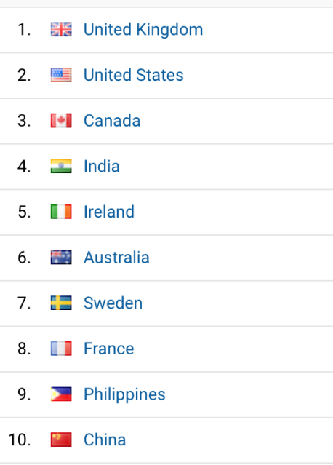

Over the past year global engagement continues to be primarily from the UK. Sweden was new to the top ten which could indicate an emerging / developing interest in the concept from this country.

January 2014 – October 2018
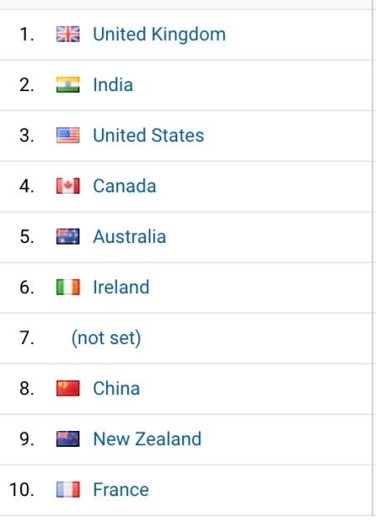
Global reach from since the IPLA started shows the UK, India, US, Canada and Australia as the top 5 visiting countries.

Membership
October 2018
There are currently 260 active subscribers out of a total of 423 total engagements the difference in number is a result of non-renewals or visitors creating an account for a conference but not purchasing a membership. This highlights that there is room for improvement when encouraging subscriptions but also alludes to a retention issue. This could be a result of technical payment issues (out of date details) but is most probably due to a lack of value when renewing the subscription.

This concludes the secretary’s report. I wish the new incoming secretary all the best for the forthcoming year.

Liz Durden-Myers
10th October 2018.

Response/Questions:
Sport for Life Conference being hosted in Sweden in 2019, may be reason for traffic from that area. Massive business. Potential for collaboration? Issues in the past, and issues with integrity. The hope is to build reciprocal relationships. Recognise that the IPLA is small, how can we work with big commercial organisations.
- Elections:
- Chair- Nigel Green, proposed MW, seconded EDM. Motion carried all agreed.
- Vice Chair-Liz Durden-Myers, proposed MW, seconded NG. Motion carried all agreed.
- Secretary-Liz Durden-Myers, proposed NG, seconded MW. Motion carried all agreed.
- Treasurer-Nigel Green, proposed EDM, seconded MW. Motion carried all agreed.
- Motions from members
From Patricia Maude - That the IPLA establishes representative links with practitioners working with babies and young children, other than in Educational settings, including:
- Parents
- Managers and Practitioners in Early Years settings
- Health Visitors and the Medical Profession
- National Governing Bodies (NGBs)

This was noted and the committee will discuss it at their next meeting
- Date and time of next meeting
Provisionally to be in November 2019. Alternative circa 10th June 2019. Next AGM to be confirmed in separate committee meeting.
Thanks go to everyone for attending.
Minutes taken by Hannah Goss

