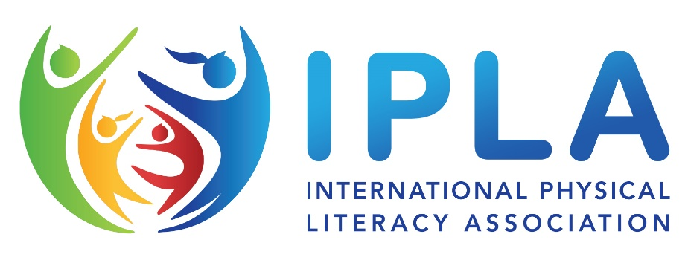
Could you be a physical literacy consultant?
Invitation to apply to join a global team of consultants, practitioners and researchers.

Background
The International Physical Literacy Association (IPLA) is a registered charity in England, formed in 2014 to promote and encourage the adoption of physical literacy across the life course in accordance with the philosophy and approach advocated by its founder, and President - Dr Margaret Whitehead in her various texts and publications.
The philosophy and concept of Margaret’s writings have been adopted and adapted in many countries and in many settings, and it is being increasingly referenced and applied in policy and practice worldwide.
Many countries and groups have established their own “physical literacy groups”, but the IPLA is the only global entity which works to advocate and implement Margaret’s specific version of physical literacy across the world – the body of work which is most usually referenced as the seminal text.
Recent years have seen an exponential growth in the organisation’s profile and activity alongside a growth in popularity and application of the physical literacy philosophy within national and international policy and practice.
In response to this growth, the IPLA’s Board of Trustees is keen to recruit a highly motivated and skilled consultancy team of practitioners and researchers to support our global work. Members of this team would be invited to express interest to lead or support projects on behalf of the IPLA on an “as and when” basis. As such, each deployment would be agreed on a voluntary and/or self-employed basis, with the assumption and agreement that any tax liability associated with such work would be the responsibility of the individual concerned.
How to Apply
To express an initial interest to join this team, applicants should be current members of the IPLA – you can join via the website here and should write a cover letter which outlines your interest and includes:
- Your personal details and current / recent professional roles
- Your current or previous history with physical literacy and the IPLA
- Your current understanding of the core principles of physical literacy
- Your thoughts on how and where physical literacy could or should be developed and promoted in your own country of residence.
Registrations of interest should be received on or before 30th January 2024, following which a short-listing process will identify those who are to progress to interview.
Please send your expressions of interest to Trevor Smith (Vice Chair) no later than 30th January 2024
Trevor.smith@physical-literacy.org.uk

